## Reports/Inventory Reports/Drug Greater than $1000

Request:

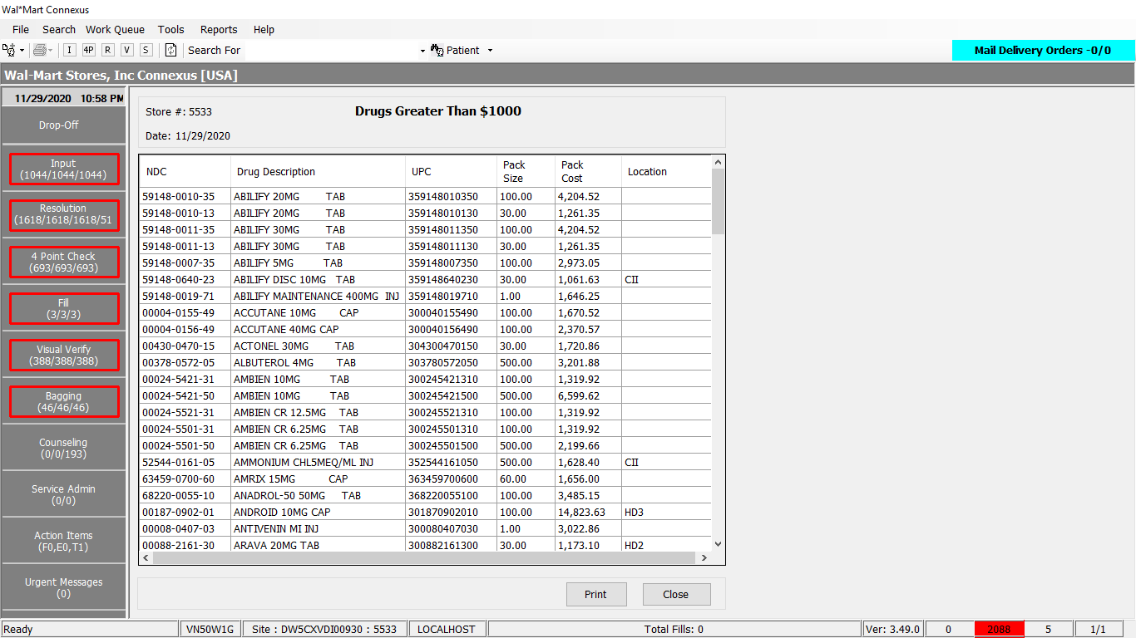

Response:



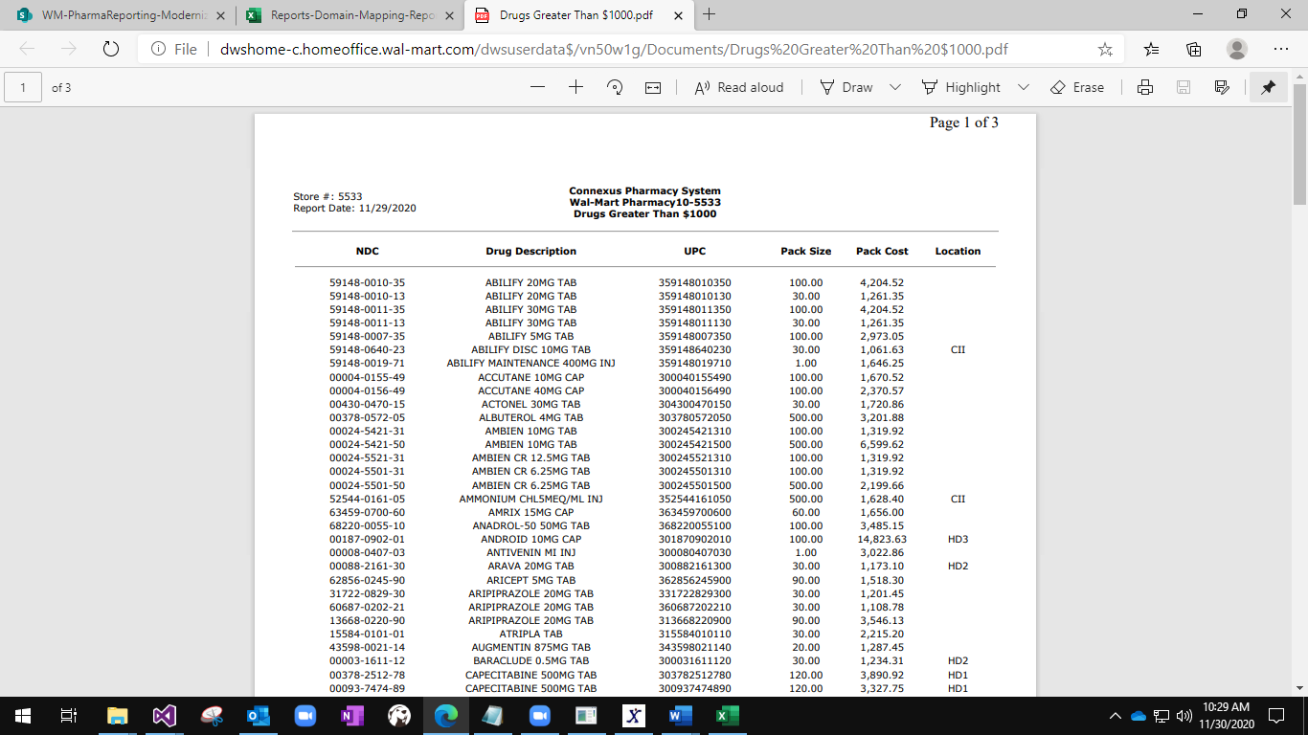

Query:

Public Const GetDrugCostInfo As String = " SELECT " &

" UPPER( pp.short_name ) As description, " &

" pi.ndc_nbr,pi.upc_nbr, " &

" (pi.INNER_PACK_QTY*pi.OUTER_PACK_QTY) As packsize, " &

" (pi.INNER_PACK_QTY*pi.OUTER_PACK_QTY*pic.phm_item_cost_amt) As packcost, " &

" NVL(pir.issued_id_nbr, '' ) AS location " &

" FROM " &

" pharmacy_offering:pharmacy_item pi, " &

" pharmacy_offering:phm_item_cost pic, " &

" pharmacy_offering:pharmacy_product pp, " &

" OUTER(pharmacy_offering:phm_item_ref pir) " &

" WHERE " &

" pi.mds_fam_id = pic.mds_fam_id " &

" AND pi.on_hand_qty > 0 " &

" AND pic.cost_type_code = 3001 " &

" AND pic.effective_date =(SELECT MAX( effective_date ) " &

" FROM pharmacy_offering:phm_item_cost pic2 " &

" WHERE pi.mds_fam_id = pic2.mds_fam_id " &

" AND pic2.cost_type_code = 3001 ) " &

" AND pi.product_mds_fam_id = pp.product_mds_fam_id " &

" AND pir.mds_fam_id = pi.mds_fam_id " &

" AND pir.phm_item_ref_code = 3105 " &

" AND (pi.INNER_PACK_QTY*pi.OUTER_PACK_QTY*pic.phm_item_cost_amt) > 1000 " &

" ORDER BY " &

" pp.short_name ASC"

DAL:

Public Function GetDrugCostInfo(ByVal siteId As Integer) As List(Of ReturnToStockInfoBE) Implements IItemDAL.GetDrugCostInfo

Using (New Tracer(ConnexusCommonConstants.ConnexusTracer))

Dim drugInfolist As New List(Of ReturnToStockInfoBE)

Dim drugInfo As ReturnToStockInfoBE

Dim local As New LocalizationManager

Try

Using dr As IDataReader = ExecuteReader(DatabaseEnum.Pharmacy_Offering, siteId, ItemQueries.GetDrugCostInfo)

While dr.Read

drugInfo = New ReturnToStockInfoBE

drugInfo.Description = dr.GetValueOrDefault(Of String)("description").SafeTrim

drugInfo.NDC = String.Format(local, "{0:N}", dr.GetValueOrDefault(Of String)("ndc_nbr").SafeTrim)

drugInfo.UpcNbr = dr.GetValueOrDefault(Of Decimal)("upc_nbr")

drugInfo.PackSize = dr.GetValueOrDefault(Of Decimal)("packsize")

drugInfo.PackCost = dr.GetValueOrDefault(Of Decimal)("packcost")

drugInfo.IssuedIdNbr = dr.GetValueOrDefault(Of String)("location")

drugInfolist.Add(drugInfo)

End While

End Using

Catch ex As Exception

drugInfolist = Nothing

End Try

Return drugInfolist

End Using

End Function